Online Shopping System: FootFusion

Software Architecture Document

Version <1.0>

Revision History
Date | Version | Description | Author
<19/11/2024> | <1.0> | Final Draft | Bùi Minh Quân

Table of Contents
1. Introduction 4
1.1 Purpose 4
1.2 Scope 4
1.3 Definitions, Acronyms, and Abbreviations 4
1.4 References 4
1.5 Overview 4
2. Architectural Representation 4
3. Architectural Goals and Constraints 4
4. Use-Case View 5
4.1 Use-Case Realizations 6
5. Logical View 17
5.1 Overview 17
5.2 Architecturally Significant Design Packages 18
6. Process View 28
7. Deployment View 28
8. Implementation View 28
8.1 Overview 28
8.2 Layers 28
9. Data View (optional) 28
10. Size and Performance 28
11. Quality 28

Software Architecture Document

Introduction
Website: https://www.figma.com/design/ECtbT8UIwBYly3Cynrents/SAD?node-id=0-1&node-type=canvas

Purpose
The Software Architecture Document provides a summary of the system's architecture and illustrates various system components from a range of architectural perspectives. Its purpose is to discuss and document significant architectural choices made for the system.

Scope
The Software Architecture Document bases on the FOOTFUSION’s System.

Definitions, Acronyms, and Abbreviations
User – A person who use the system of FOOTFUSION with the demand to buy stuff (buyers and sellers).
Seller – A person who has FOOTFUSION’s account to sell stuff.
Buyer – A person who has FOOTFUSION’s account to buy stuff.
Admin – A person or maybe a group that FOOTFUSION has hired to operate the system.

References
None.

Overview
The system architecture is thoroughly explained in the parts that follow. First, the architectural representation that describes the current system's design and how it is displayed. The objective and architectural restrictions come in second. This section outlines the software objectives and requirements that significantly affect the architecture. The use case view section that follows lists the use cases that correspond to the main system functions. The next view parts go into great detail into the system's internal design. Finally, there are size, performance, and quality criteria that will be suggested.

Architectural Representation
This paper shows the architecture of: Use-Case View, Logical View and Deployment View. They are described by diagrams that we have used the website called “draw.io”, “WhiteStarUML” and of course, Unified Modeling Language (UML).
- Use- Case View:
+ Users: including buyer and seller.
+ Field: shows the use-case situations and the function of them which can affect to the FOOTFUSION’s System.
+ Related Artifacts: Use-Case Realization and Use-Case Specification.
- Logical View:
+ Users: admin.
+ Field: the design’s model.
+ Related Artifacts: Design Model.
- Deployment View:
+ Users: admin.
+ Field: illustrates the diagram from software to hardware.
+ Related Artifacts: Deployment Model

Architectural Goals and Constraints

As the name of Architecture, with them, the design of model can be created with the critical thinking to make the system works. Besides, there will be existed some constraints that the system cannot avoid.

With the Goals:

The System can be seen in the brief eyes so that it can be implemented fluently.

The architecture will list all the needed attributes for the system to work with.

The architecture runs on the dedicated platforms which can access the database.

The architecture is built to allow the reuse of business logic on applications.

With the Constraints:

The architecture of system must be designed to meet all of the requirements.

All the information has to be filled before started.

All access must be approached by users’ account and password that are registered.

Use-Case View

As the use-case specification and use-case realization we have done above, the set of scenarios and use cases that are the concentrate on an iteration. Here are the main functions of the LOVESCENE’s system that we mentioned about.

The use cases about the system are listed below:
- Manage Information
- Manage Products
- Manage Shopping Cart
- Manage Payment Methods
- Tracking Shipping Process
- Buyer Manage Order
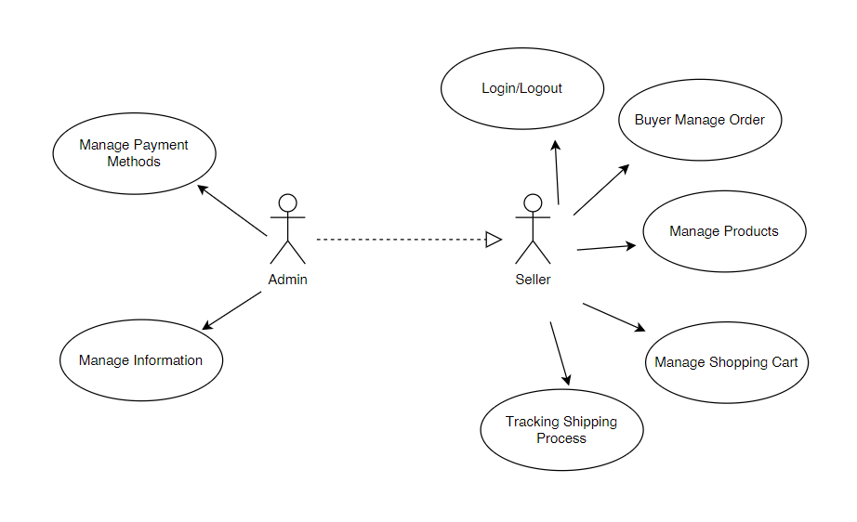

Use-Case Realizations

4.1.1. Login/Logout:
- Brief Description: Admin and users can login/logout account. With admin, they have to login with the registered account that FOOTFUSION’s System provides. With users, they have to create account and login with the right personal information.
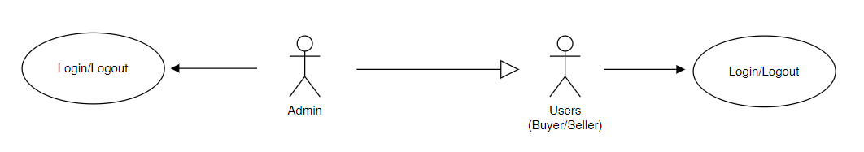

4.1.2 Manage Payment Methods:
- Brief Description: Admin can manage payment methods information.
- Specification: Reference with Use-Case Specification: Add/Delete/Update/View Payment Methods for more details.
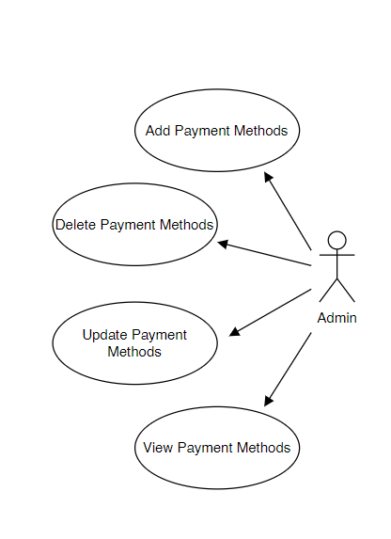

4.1.3. Manage Products:
- Brief Description: Admin and sellers can manage products information.
- Specification: Reference with Use-Case Specification: Add/Delete/Update/View Products for more details.
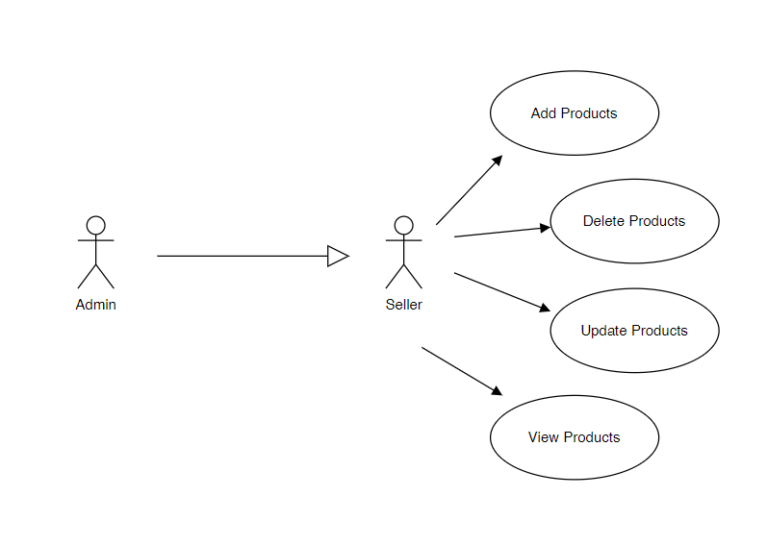
4.1.4. Manage Tracking Shipping Process:
- Brief Description: Admin and sellers can manage tracking shipping process information.
- Specification: Reference with Use-Case Specification: Shipping Management.
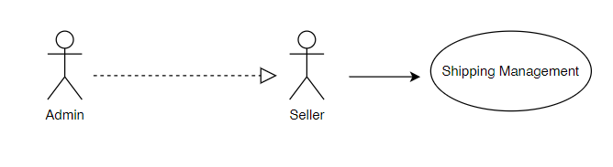
4.1.5. Manage Information:
- Brief Description: Admin can manage update FOOTFUSION’s Information for information.
- Specification: Reference with Use-Case Specification: Update FOOTFUSION’s Information Payment Methods for more details.
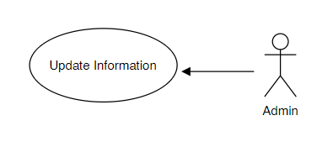

4.1.6. Manage Shopping Cart:
- Brief Description: Admin and buyers can manage shopping cart information.
- Specification: Reference with Use-Case Specification: Add/Delete Products in the Cart for more details.
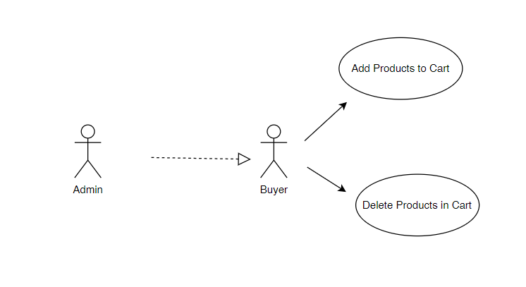

4.1.7. Buyer Manage Order:
- Brief Description: Admin and buyers can manage order information.
- Specification: Reference with Use-Case Specification: Search and View, Create and Cancel Buyer Order for more details.
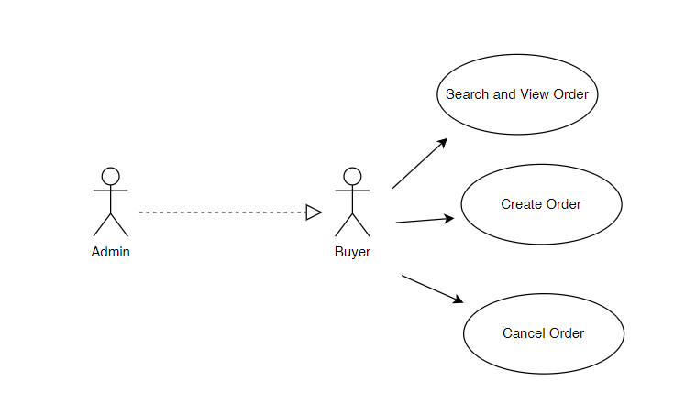

Logical View

Overview
In logical view, we will stan will three elements that are so important to design the architecture for any system, in this situation is PerfumeParasise’s Company. With the design model in terms of package hierarchy and layers, there are:
- Model: Manage the data process.
- View: Display the interface for users.
- Controller: Control the relationship between Model and View.
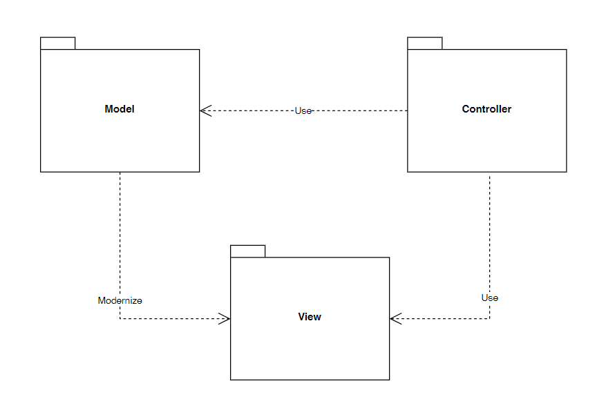

Architecturally Significant Design Packages
5.2.1. Model Package:

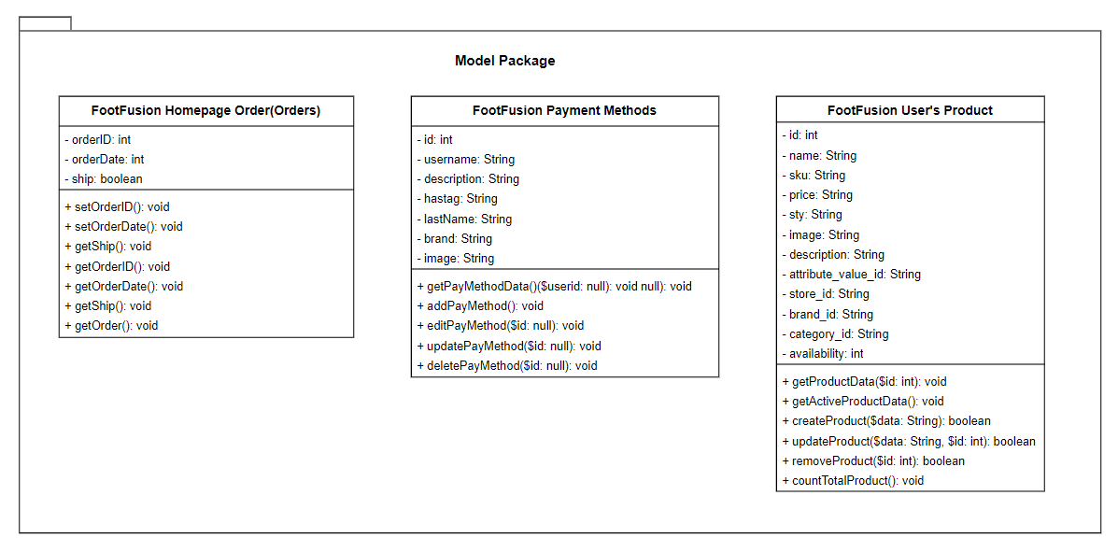

Name | Model Package
Brief Description | Includes all the classes of data that use case specifications and use case realizations mentioning about, with the logic and rules of the Online Shopping System: FOOTFUSION.
Classes | Orders, Products, PaymentMethods.

- Products Class:
Name | Product
Brief Description | Data prototype for file table in the database parameter.

Attributes
Name | Type | Access | Mutable | Optional | Length | Min | Max
id | int | Private | F | F | 11 | N/A | N/A
name | String | Private | T | F | 255 | N/A | N/A
sku | String | Private | T | F | 255 | N/A | N/A
price | String | Private | T | F | 255 | N/A | N/A
qty | String | Private | T | F | N/A | N/A | N/A
image | String | Private | T | F | N/A | N/A | N/A
description | String | Private | T | F | N/A | N/A | N/A
attribute_value_id | String | Private | T | F | N/A | N/A | N/A
brand_id | String | Private | T | F | N/A | N/A | N/A
category_id | String | Private | T | F | N/A | N/A | N/A
store_id | int | Private | T | F | 11 | N/A | N/A
availability | int | Private | T | F | 11 | N/A | N/A

- PaymentMethods Class:
Name | PaymentMethods
Brief Description | Data prototype for file table in the database parameter.

Attributes
Name | Type | Access | Mutable | Optional | Length | Min | Max
id | int | Private | F | F | 11 | N/A | N/A
username | String | Private | T | F | 255 | N/A | N/A
description | String | Private | T | F | 255 | N/A | N/A
hastag | String | Private | T | T | 11 | N/A | N/A
lastName | String | Private | T | F | 11 | N/A | N/A
brand | String | Private | F | T | 11 | N/A | N/A
image | String | Private | T | T | N/A | N/A | N/A

- Orders Class:
Name | Order
Brief Description | Data prototype for file table in the database parameter.

Attributes
Name | Type | Access | Mutable | Optional | Length | Min | Max
orderID | int | Private | F | F | 11 | N/A | N/A
ordership | int | Private | T | F | 255 | N/A | N/A
ship | String | Private | T | F | N/A | N/A | N/A

5.2.2. View Package:

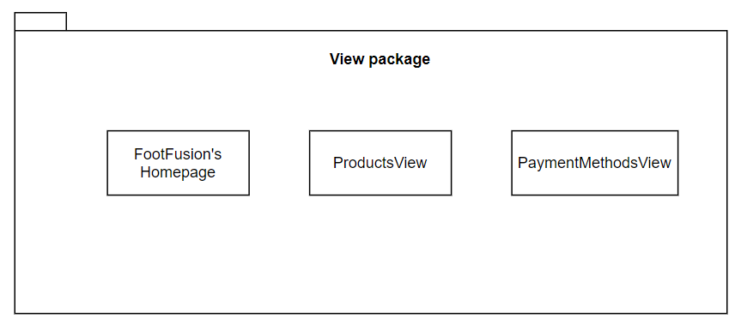

5.2.3. Controller Package:

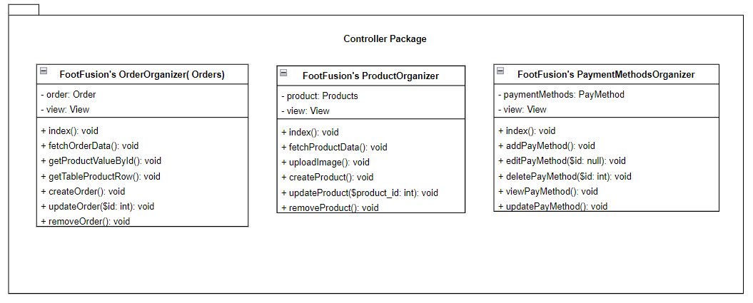

Name | Model Package
Brief Description | Includes all the classes of data that use case specifications and use case realizations mentioning about, with the logic and rules of the Online Shopping System: FOOTFUSION.
Classes | OrderOrganizer, ProductsOrganizer, PaymentMethodsOrganizer

- ProductsOrganizer Class:
Name | ProductsOrganizer
Brief Description | Controller for handling operations related to products.

Attributes
Name | Type | Access | Mutable | Optional | Length | Min | Max
product | Products | Private | T | F | N/A | N/A | N/A
view | View | Private | T | F | N/A | N/A | N/A

Operations
Header | Return Type | Access | Scope | Specification
index() | void | Public | Instance | Redirect to manage orders page
createProduct() | void | Public | Instance | Create new Products
updateProduct() | void | Public | Instance | Update new Products
removeProduct() | void | Public | Instance | Remove the Products
fetchProductsData() | void | Public | Instance | Fetch the products value from the products table
updateImage() | void | Public | Instance | Update new Image

- PaymentMethodsOrganizer:
Name | PayMethodOrganizer
Brief Description | Controller for handling operations related to paymethod page.

Attributes
Name | Type | Access | Mutable | Optional | Length | Min | Max
paymentMethods | PayMethod | Private | T | F | N/A | N/A | N/A
view | View | Private | T | F | N/A | N/A | N/A

Operations
Header | Return Type | Access | Scope | Specification
index() | void | Public | Instance | Redirect to manage PayMethod page
addPayMethod() | void | Public | Instance | Add new PayMethod
editPayMethod() | void | Public | Instance | Edit new PayMethod
deletePayMethod() | void | Public | Instance | Delete the PayMethod
viewPayMethod() | void | Public | Instance | View the paymethod value from the Pay Method table
updatePayMethod() | void | Public | Instance | Update the paymethod from the Pay Method page

- OrdersOrganizer Class:
Name | OrdersOrganizer
Brief Description | Controller for handling operations related to orders.

Attributes
Name | Type | Access | Mutable | Optional | Length | Min | Max
order | Orders | Private | T | F | N/A | N/A | N/A
view | View | Private | T | F | N/A | N/A | N/A

Operations
Header | Return Type | Access | Scope | Specification
index() | void | Public | Instance | Redirect to manage orders page
createOrders() | void | Public | Instance | Create new Orders
updateOrders() | void | Public | Instance | Update new Orders
deleteOrders() | void | Public | Instance | Delete the Orders
fetchOrdersData() | void | Public | Instance | Fetch the orders value from the orders table
getProductValueByID() | void | Public | Instance | Retrieves the particular product data from the product ID
getTableProductRow() | void | Public | Instrance | Get the all the active product information from the product table

Process View

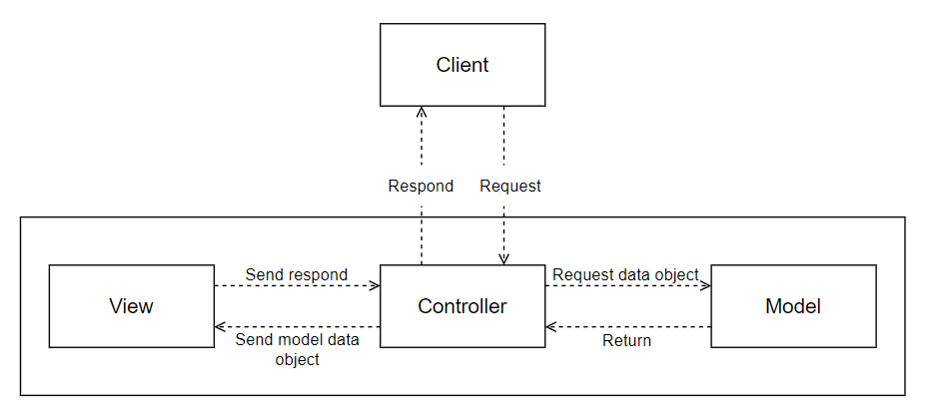

Deployment View
Deployment View is a drawing diagram that helps admin to identify the implementation of the data process. Besides, deployment view will provide the information for admin to put components in the system to the right positions.

Implementation View
None.

Data View (optional)

Size and Performance

The time respond for the system has to be less than 2 minutes.

The system has to save the information correctly. After that, the interface must display the same information.

The system must perform the functions and tasks with the lowest waiting.

Quality
The products that we choose to analyze achieve the following quality:
- Speed: the system has fast transfer to each function.
- Security: the system is safe with the account has to registered with personal information.
- Adaptability: the system is based on the user experience to be built with friendly interface for users to adapt and use.
- Scalability: the system is always updated due to the special events. In this case, it will check and fix errors if they happened.
- Maintenance: with the MVC model, they system is easy to be upgraded and maintained for a long time.

